Task- 9
class Solution {
public List<String> stringMatching(String[] words) {

List<String> result = new ArrayList<>();

for (int i = 0; i < words.length; i++) {

for (int j = 0; j < words.length; j++) {

if (i != j && words[j].contains(words[i])) {
result.add(words[i]);
break;
}
}
}

return result;
}
}

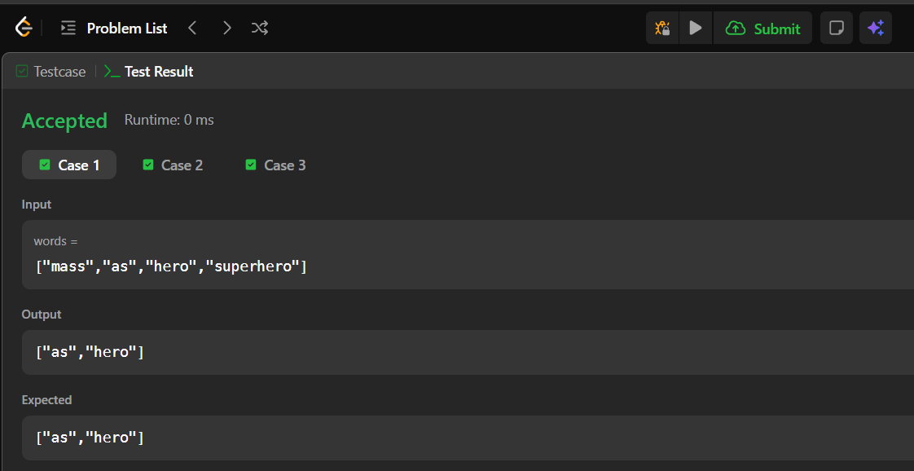

Task-10
import java.util.ArrayList;

public class GFG {

// Function to search for all occurrences of 'pat' in 'txt' using Naive Approach
static ArrayList<Integer> search(String pat, String txt)
{
// Length of the pattern
int m = pat.length();

// Length of the text
int n = txt.length();

ArrayList<Integer> ans = new ArrayList<>();

// Slide the pattern over text one by one
for (int i = 0; i <= n - m; i++)
{
int j;

// Check for pattern match at index i
for (j = 0; j < m; j++)
{
if (txt.charAt(i + j) != pat.charAt(j))
break;
}

// If pattern matches, store index
if (j == m)
ans.add(i);
}

return ans;
}

public static void main(String[] args)
{
String txt = "aabaacaadaabaaba";
String pat = "aaba";

ArrayList<Integer> res = search(pat, txt);

for (int it : res)
{
System.out.print(it + " ");
}
}
}
